Q2, What is the purpose of <a> tag in html ? write the syntax for creating a hyperlinks and explain each part.
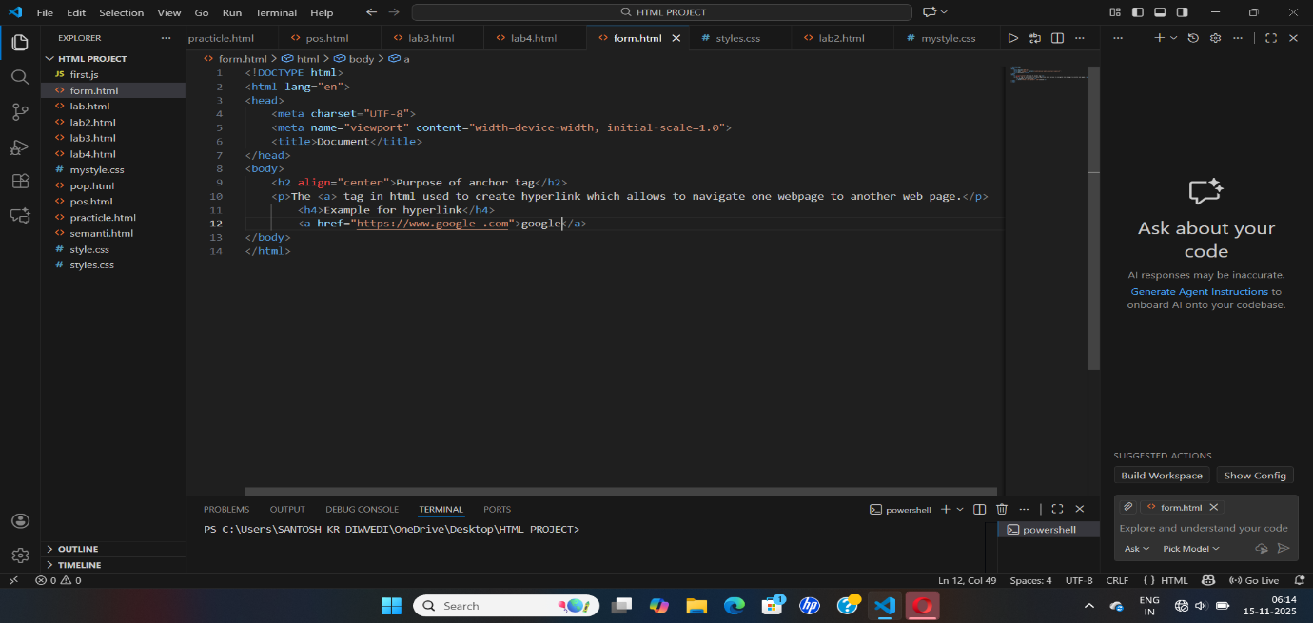
Output-
